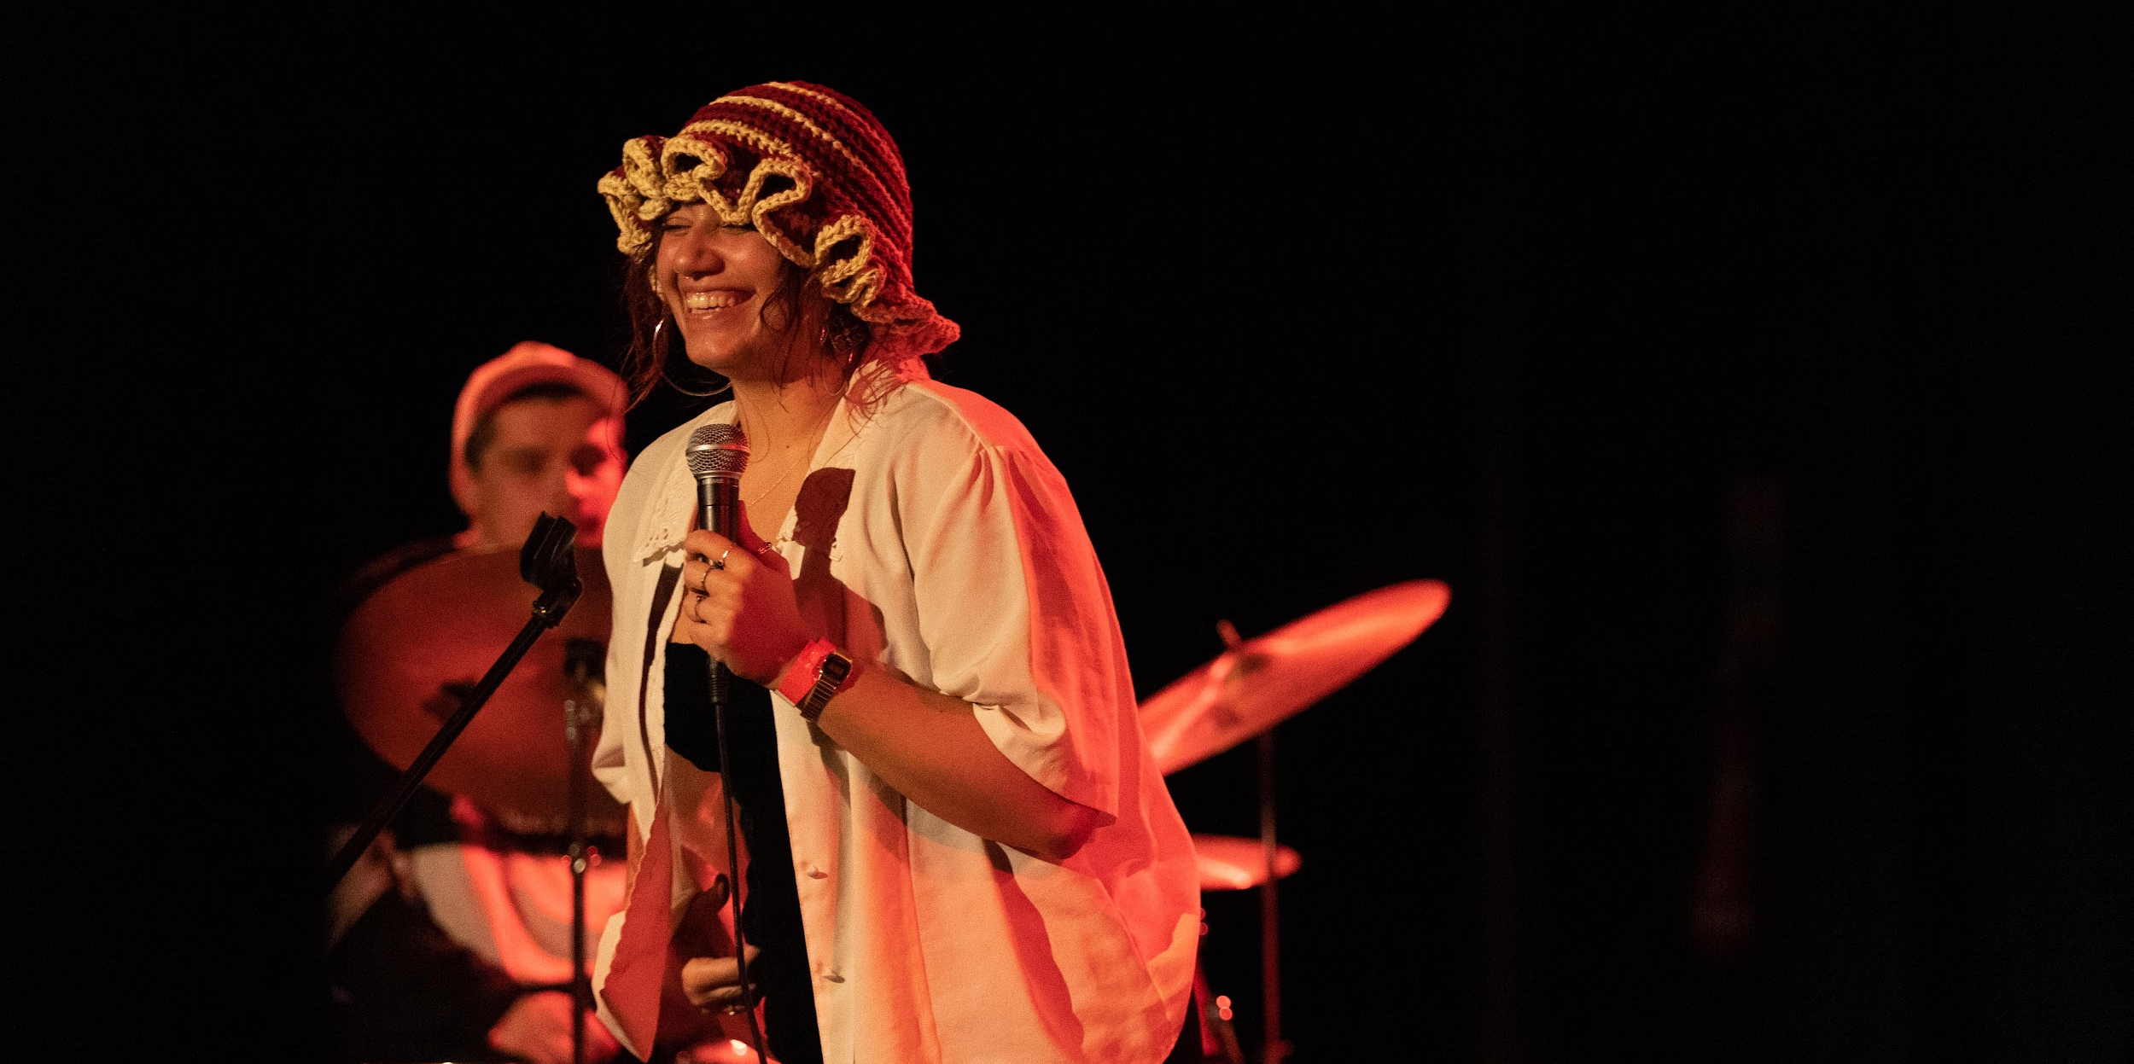
BLUEPRINT: PRODUCER TRAINING PROGRAMME

BLUEPRINT is a space to learn by doing. At its heart, it’s an opportunity for people who might otherwise never work professionally in theatre to develop their skills in producing and programming and create change in a sector that desperately needs new voices.

The emerging producers we select will meet regularly, whilst learning from the TFT Arts Team. Together they will curate and programme events that take place at TFT. It is our aim to ignite and support the trainee producers and hope that in turn, we too will be inspired and guided by their ideas.

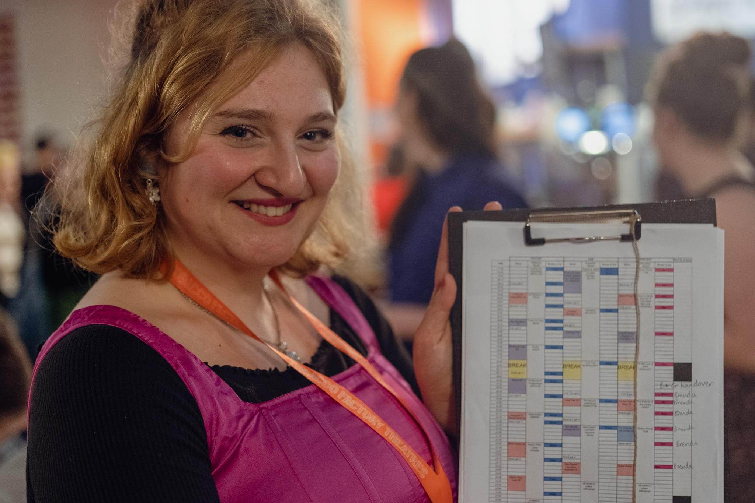

COURSE CONTENT
Over 9 months we will give a detailed introduction to programming and producing theatre, with each workshop focussing on a specific area of work. Key sections of this course have been carefully planned and others left purposefully open, allowing space for the content and work to be driven and influenced by those in the room.

These workshops will be held fortnightly, and on the weeks in between you will be invited to work together in the theatre with your fellow trainees as you work towards presenting SPARK - a one night festival of scratch theatre programmed, produced and designed by you and your cohort. This is a core part of your learning - everything you learn in workshops will be put into practice by producing this festival.

Trainee Producers will take part in fortnightly workshops at the theatre from May 2023 - Feb 2024 with short breaks in the summer and winter. Workshops will be delivered in most by Resident Blueprint Producer Graham Johnson (www.GrahamMacLeodJohnson.com)

This year we will be partnering with We The Curious to provide opportunities for our trainee producers. We The Curious is an educational charity and South West England’s leading science centre. They produce experiences that bring people together to play, get creative with science and explore different ideas. They work with partners locally and nationally, supporting people to be inquisitive, develop new skills and improve their wellbeing. Their vision asks ‘what if everyone is included, curious and inspired by science to build a better world together?’

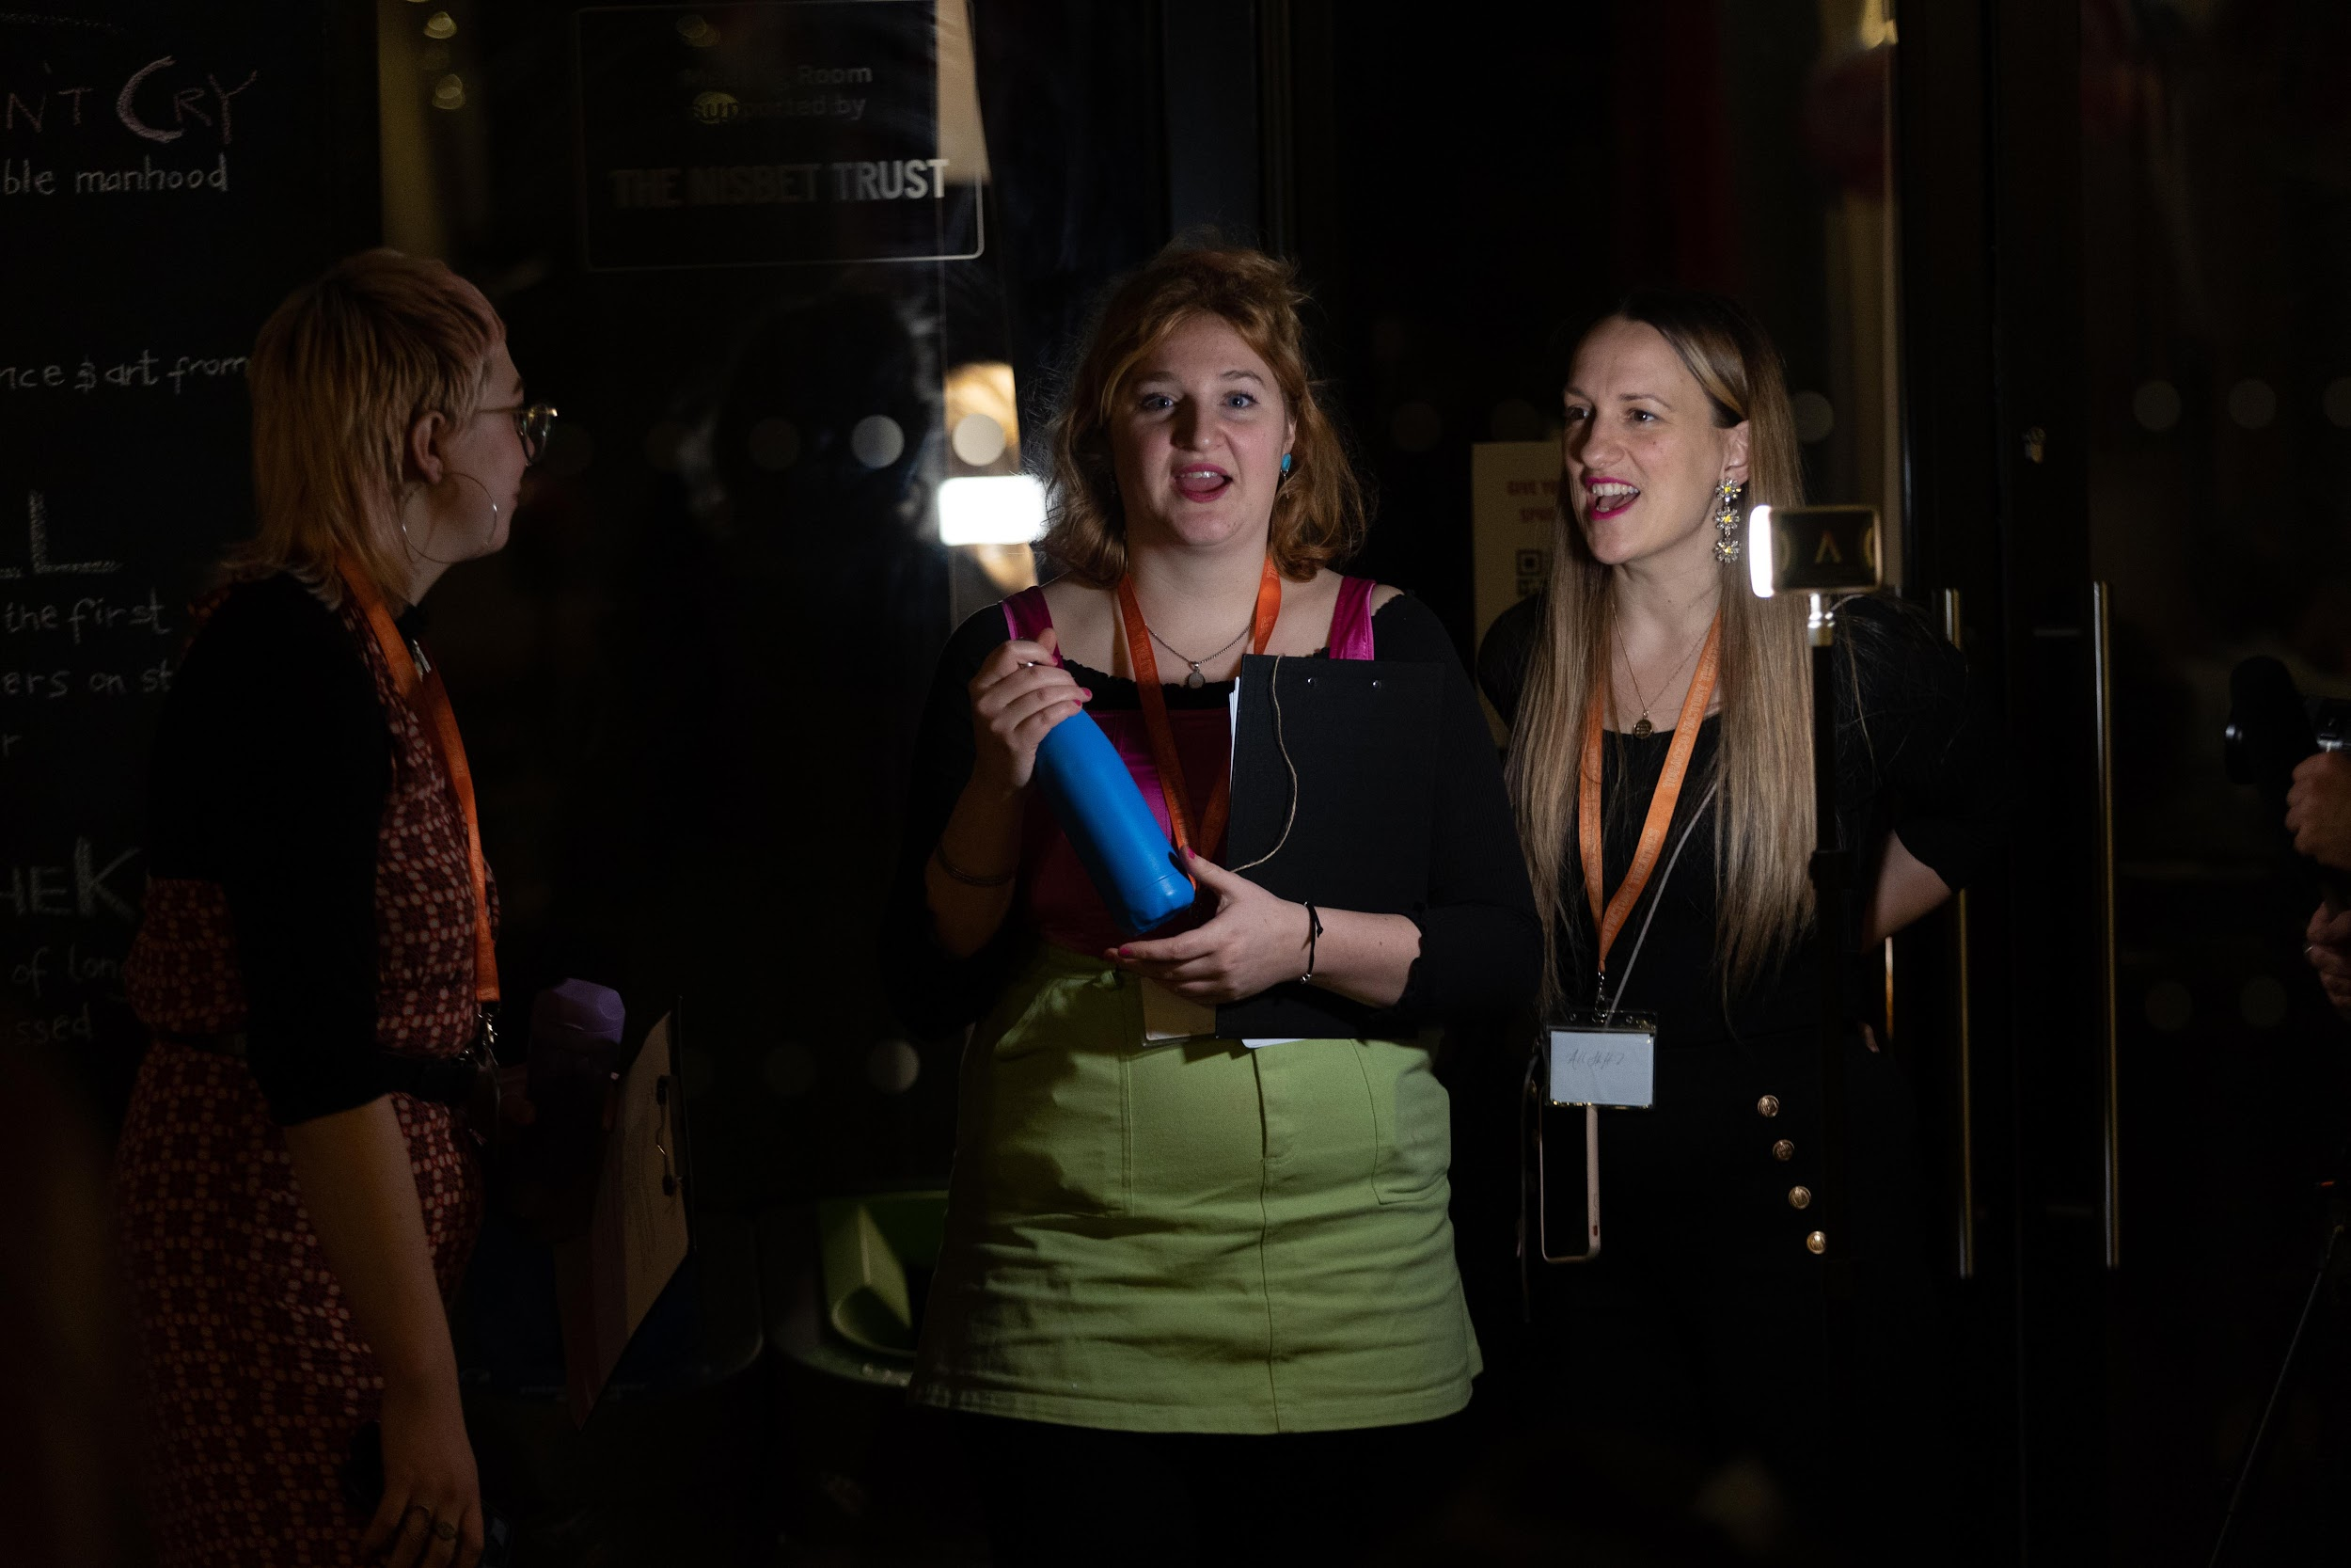
Over the course of the programme you will learn about:
- Budgeting and cash flow management
- Programming
- Networking
- Partnerships
- Marketing
- Scheduling
- Venue Liaison
- Artist Liaison
- Operations, Technical and Health and Safety
- Fundraising and evaluation
- Co-Producing and negotiating deals
- Wellbeing and care
- Hands on learning producing a festival of new work by emerging artists
WHY ARE WE DOING IT?
We recognise the national need for an inclusive artistic workforce and believe the future of theatre is dependent on this endeavour.
We hope through offering meaningful, practical training where we can create real pathways into work for people regardless of gender, class, identity.
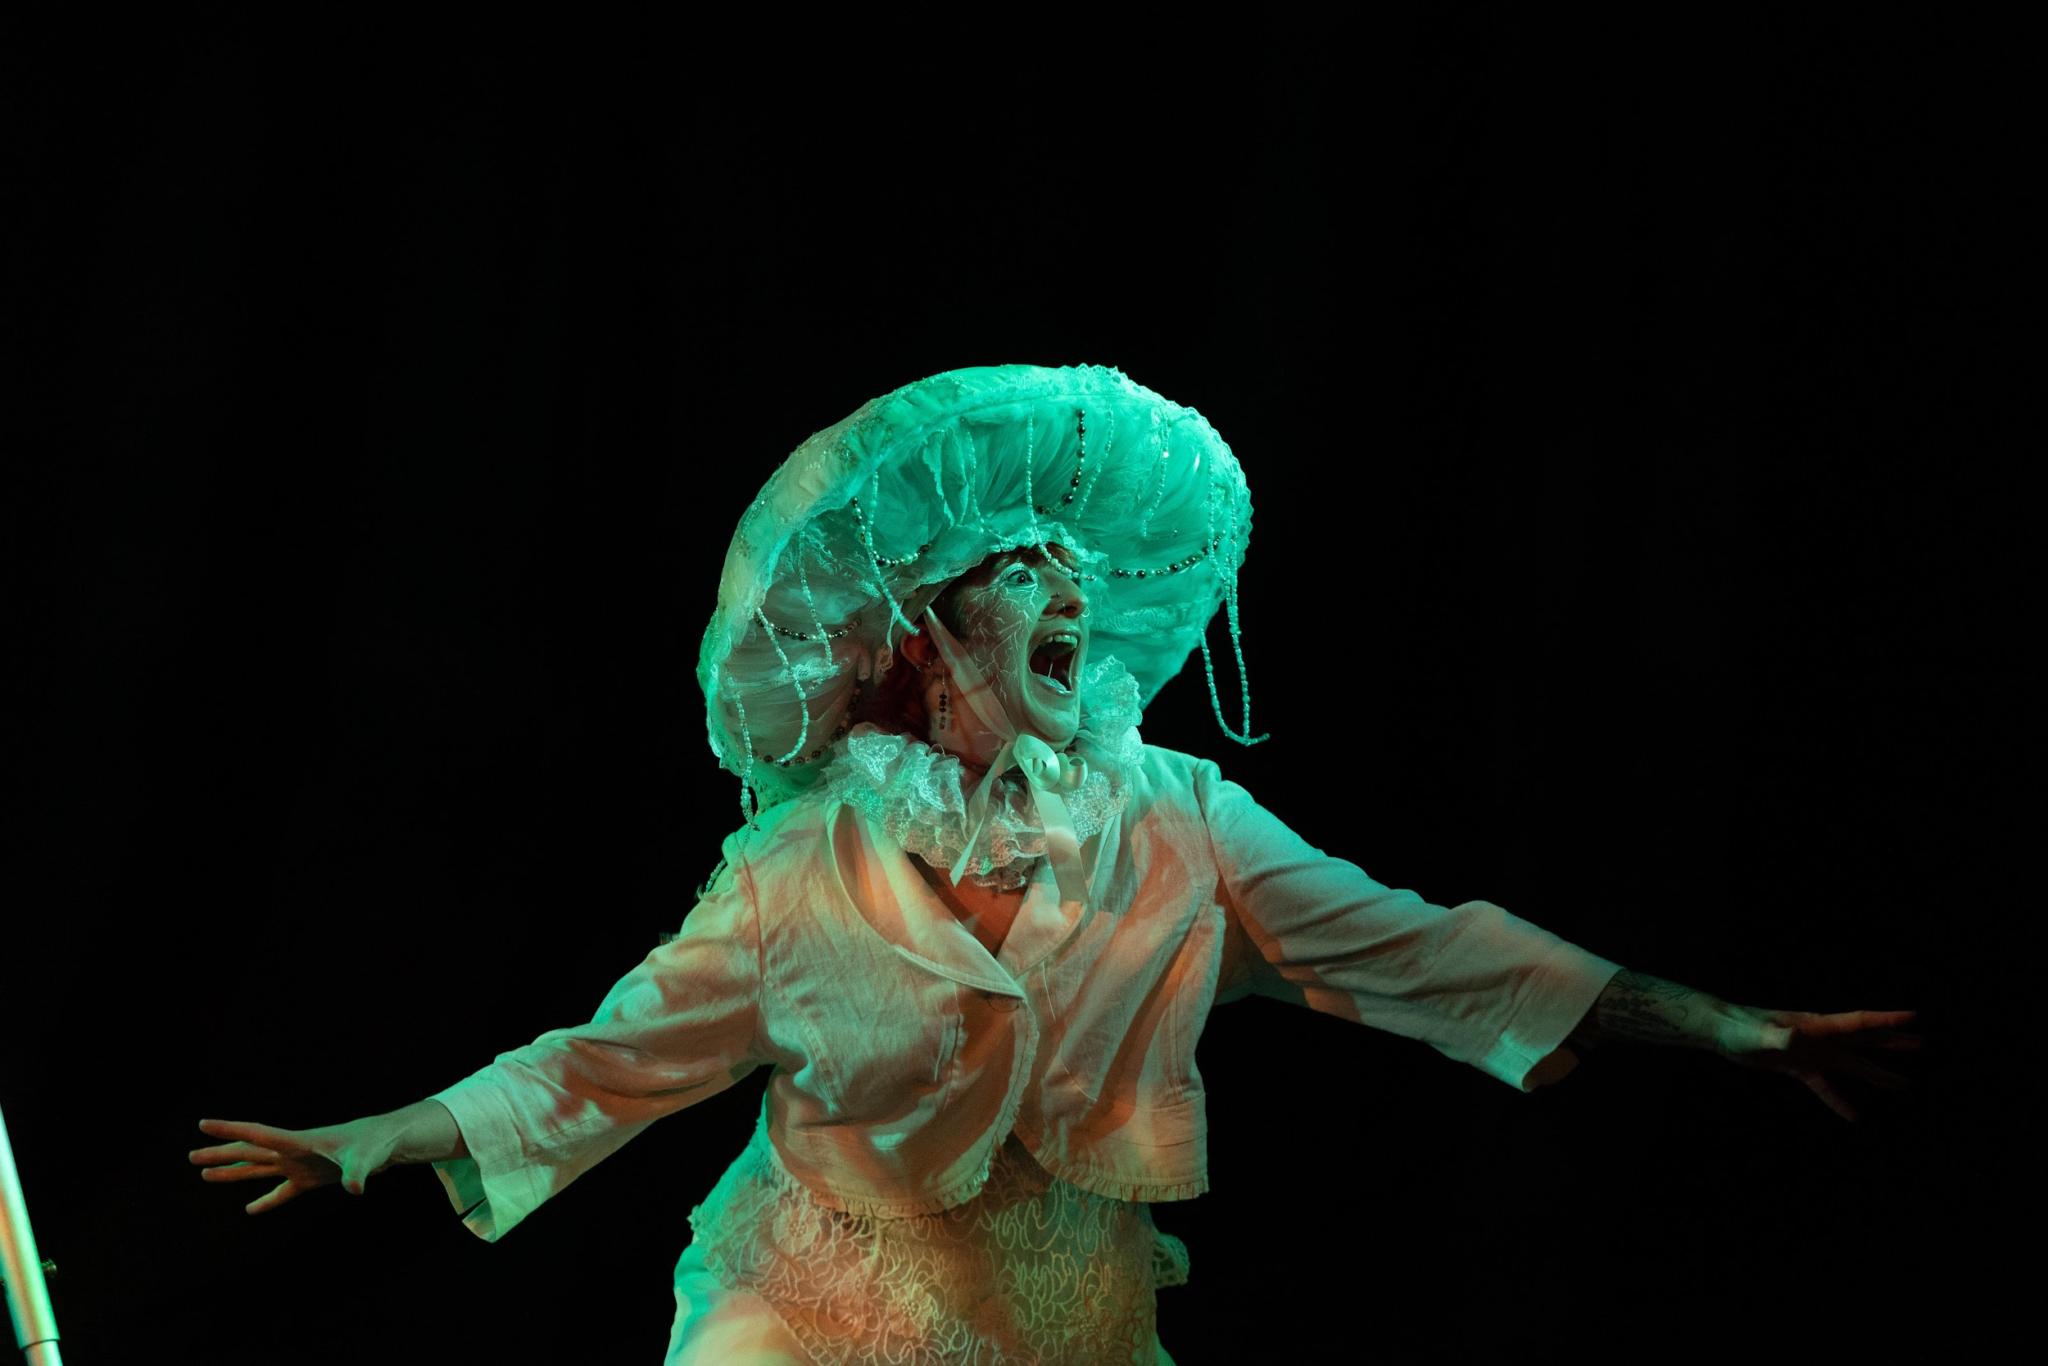
We encourage those who take part to be forward thinking, to challenge us, to question the status quo, to be the makers of a new future.
WHO IS IT FOR?
We’d love to hear from you if you:
- are aged 18+
- live in Bristol
- are up for getting stuck in, telling us what you really think, and making the most out of the opportunity
Maybe you are a lover of music, street art, theatre, dancing, spoken word, or politics?
Perhaps you are a performing artist and you want the skills to produce yourself and others?
You may have dabbled in producing before, or you might know this is something you want to do but havent had the chance to do so yet?
You might not even know you’ve been producing, but if you are a person who organises people and makes things happen, we want to hear from you.
If you’re not certain you’re the right person for this programme, please apply. If you need convincing, please get in touch and let us convince you.

Unfortunately we are unable to consider applications from those who are in full time education.
WHAT IS THE COMMITMENT?
- Fortnightly workshops between June 2022 and February 2023. These will take place Tuesdays, 5-8pm.
- You will be encouraged to use the theatre as a co-working space on non-working weeks but this is optional.
- This course is designed for people who are ready to commit time and energy.
- This course is offered free of charge: we understand time and energy = investment!
- We recognise the commitment and contribution you will be making to the theatre. This free training is worth £5,000 per trainee, and your work on the programme is a vital part of your learning. SPARK would never happen without BLUEPRINT and BLUEPRINT could not exist without SPARK.
- We are open to all conversations about your access needs - whether these are related to disabilities, financial situation or your general care.
- We have means tested bursaries available for those who would otherwise be unable to participate in the programme.

APPLICATION PROCESS
To apply, please send in a video or audio file of up to 4 minutes, complete the linked google form, or send us a word document of up to 600 words to artists@tobaccofactorytheatres.com, including the following information:
- Why you want to join the programme
- What you would like to get out of the programme
- What excites you about creative work
- Tell us briefly about a project you have worked on or would like to work on but haven’t had the opportunity.
- If you have worked in an arts organisation, we would find it useful to know where and what your role was. If you have produced professionally, it is likely this programme is not appropriate for you. However, we recognise how challenging it can be to break out of front of house, administrative and assistant roles, so we would encourage you to apply if you feel stuck.
Alongside this please make sure you include your name, email address and a phone number we can contact you on.
If you have any access needs, we invite you to include them alongside your application in a format that works for you.
Please send videos or audio files as an unlisted YouTube video if possible (Here is a guide if you are unsure how to do this). Quality of filming has no impact on the application, please just use your smartphone camera or webcam.
If you are from a background that is currently underrepresented in the cultural sector, for example if you are from a group that experiences racism, if you did not go to university or received free school meals as a child, or if you have a disability, PLEASE STATE THIS IN YOUR APPLICATION AND YOU WILL BE PRIORITISED FOR AN INTERVIEW. If we receive an extraordinary amount of applications, or it is felt you are too experienced for the programme, this could mean we are unable to invite you to interview.
In addition if you would like support in communicating your skills, experience or attitude, get in touch with Graham and we will help: g.johnson.rsn@gmail.com
- The deadline for submissions is 9am Monday 22nd May
- Interviews will be held online the week beginning 5th June. If you do not have access to a webcam or a private space to join the interview, let us know and we can arrange for this to be in person.
- If selected for the programme, you will be expected to join us for sessions beginning on 20th June, 5-8pm at Tobacco Factory Theatres, and will run through to late February 2024, with short breaks in August and December.

